**PROGRAM TITLE-5**

**Missionaries Cannibal problem**

**AIM:**

To write and execute the python program for Missionaries Cannibal problem.

**PROCEDURE:**

1. **Define the State Representation:**
   * Each state consists of the number of missionaries and cannibals on each side of the river, as well as the boat's location.
2. **Define the State Transition Function:**
   * Generate all possible successor states from the current state while ensuring validity.
   * Validity conditions include not having more cannibals than missionaries on either side and ensuring that the number of missionaries and cannibals doesn't exceed the total.
3. **Perform Depth-First Search (DFS):**
   * Start with the initial state where all the missionaries and cannibals are on one side of the river, and the boat is also on that side.
   * Explore successor states recursively, making sure to keep track of visited states to avoid revisiting them.
   * Backtrack if a dead-end is reached or if the state violates the constraints.
4. **Check for the Goal State:**
   * Check if the goal state, where all missionaries and cannibals have crossed to the other side, is reached.
   * If the goal state is reached, return the solution path.
5. **Implement the Algorithm:**
   * Define a State class representing the current state of the problem.
   * Define functions to generate successor states, perform DFS, and check for the goal state.
   * Use appropriate data structures to manage states and track visited states during the search.
6. **Output the Solution:**
   * Once the goal state is found, output the sequence of states that led to the solution.
   * If no solution is found, indicate that the problem is unsolvable.

s

**CODING:**

#Python program to illustrate Missionaries & cannibals Problem

#This code is contributed by Sunit Mal

print("\n")

print("\tGame Start\nNow the task is to move all of them to right side of the river")

print("rules:\n1. The boat can carry at most two people\n2. If cannibals num greater than missionaries then the cannibals would eat the missionaries\n3. The boat cannot cross the river by itself with no people on board")

lM = 3 #lM = Left side Missionaries number

lC = 3 #lC = Laft side Cannibals number

rM=0 #rM = Right side Missionaries number

rC=0 #rC = Right side cannibals number

userM = 0 #userM = User input for number of missionaries for right to left side travel

userC = 0 #userC = User input for number of cannibals for right to left travel

k = 0

print("\nM M M C C C | --- | \n")

try:

while(True):

while(True):

print("Left side -> right side river travel")

#uM = user input for number of missionaries for left to right travel

#uC = user input for number of cannibals for left to right travel

uM = int(input("Enter number of Missionaries travel => "))

uC = int(input("Enter number of Cannibals travel => "))

if((uM==0)and(uC==0)):

print("Empty travel not possible")

print("Re-enter : ")

elif(((uM+uC) <= 2)and((lM-uM)>=0)and((lC-uC)>=0)):

break

else:

print("Wrong input re-enter : ")

lM = (lM-uM)

lC = (lC-uC)

rM += uM

rC += uC

print("\n")

for i in range(0,lM):

print("M ",end="")

for i in range(0,lC):

print("C ",end="")

print("| --> | ",end="")

for i in range(0,rM):

print("M ",end="")

for i in range(0,rC):

print("C ",end="")

print("\n")

k +=1

if(((lC==3)and (lM == 1))or((lC==3)and(lM==2))or((lC==2)and(lM==1))or((rC==3)and (rM == 1))or((rC==3)and(rM==2))or((rC==2)and(rM==1))):

print("Cannibals eat missionaries:\nYou lost the game")

break

if((rM+rC) == 6):

print("You won the game : \n\tCongrats")

print("Total attempt")

print(k)

break

while(True):

print("Right side -> Left side river travel")

userM = int(input("Enter number of Missionaries travel => "))

userC = int(input("Enter number of Cannibals travel => "))

if((userM==0)and(userC==0)):

print("Empty travel not possible")

print("Re-enter : ")

elif(((userM+userC) <= 2)and((rM-userM)>=0)and((rC-userC)>=0)):

break

else:

print("Wrong input re-enter : ")

lM += userM

lC += userC

rM -= userM

rC -= userC

k +=1

print("\n")

for i in range(0,lM):

print("M ",end="")

for i in range(0,lC):

print("C ",end="")

print("| <-- | ",end="")

for i in range(0,rM):

print("M ",end="")

for i in range(0,rC):

print("C ",end="")

print("\n")

if(((lC==3)and (lM == 1))or((lC==3)and(lM==2))or((lC==2)and(lM==1))or((rC==3)and (rM == 1))or((rC==3)and(rM==2))or((rC==2)and(rM==1))):

print("Cannibals eat missionaries:\nYou lost the game")

break

except EOFError as e:

print("\nInvalid input please retry !!")

**OUTPUT:**

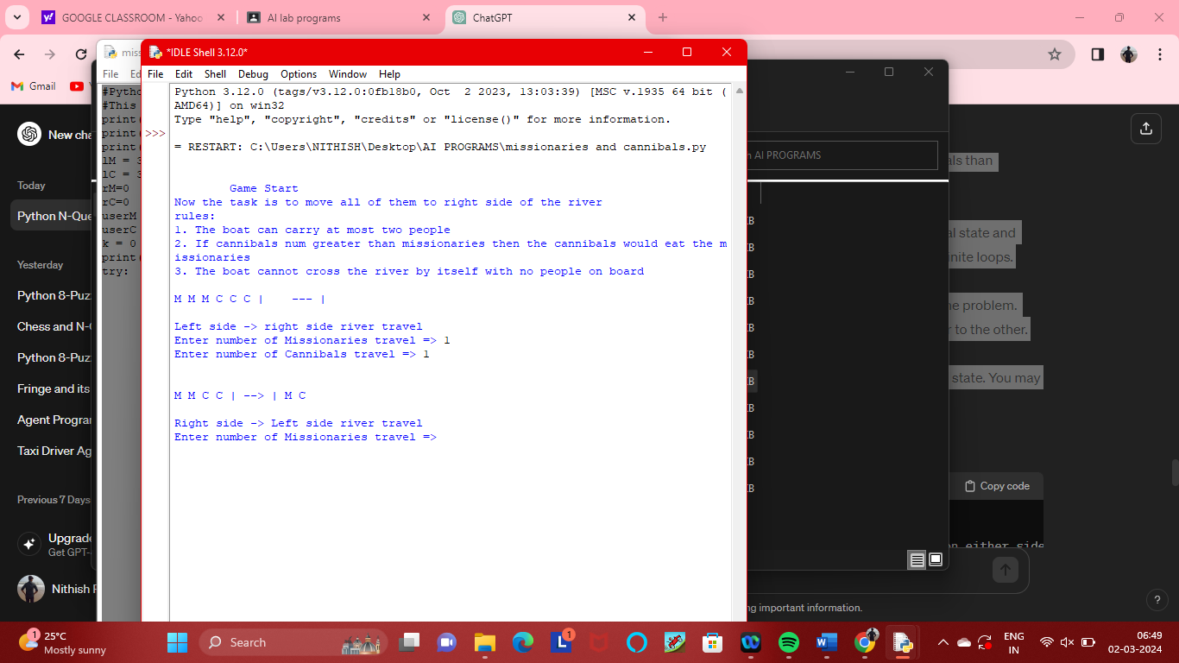

**RESULT:**

Thus the output has been successfully written and verified.